**ScreentShots of Kitchen Story Project**

**Home.js**

In the Home page all the Products are displayed here I have only taken 3 items for testing

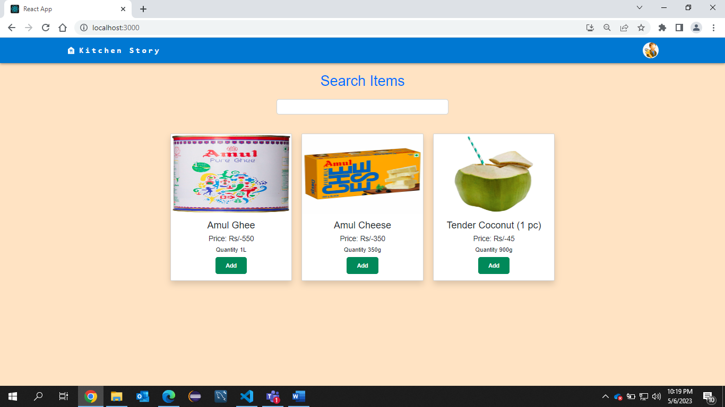

This is a real time Search as we enter the name in Search field the items will keep changing without reloading

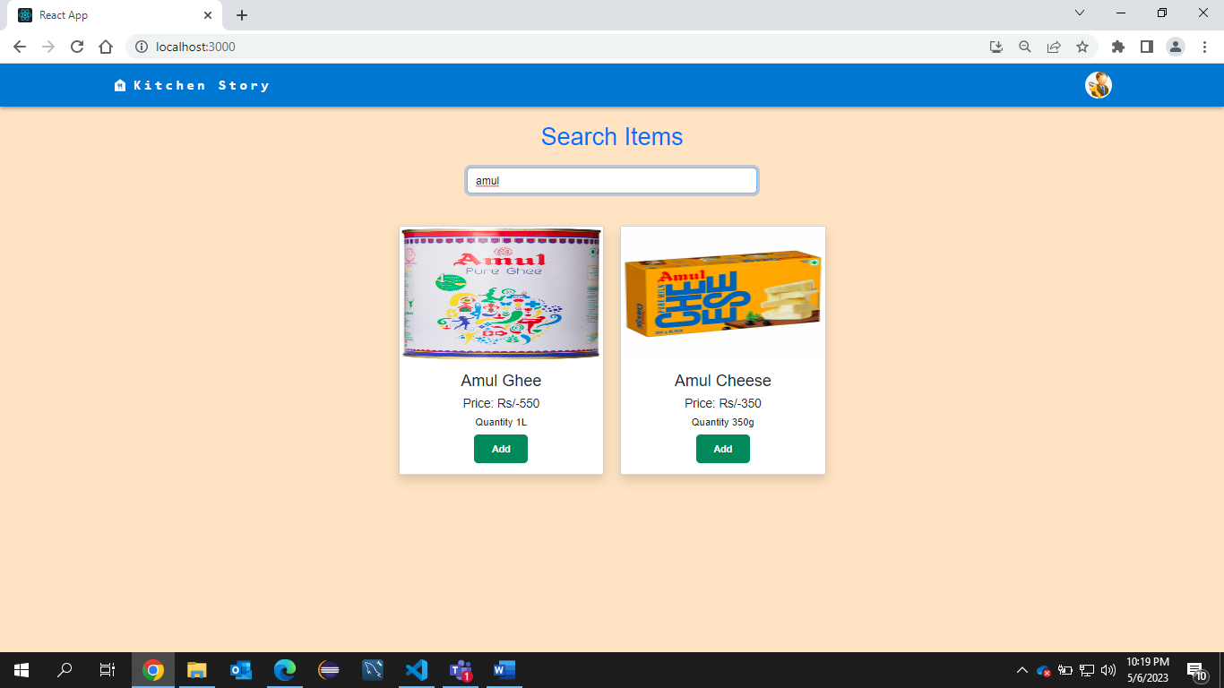

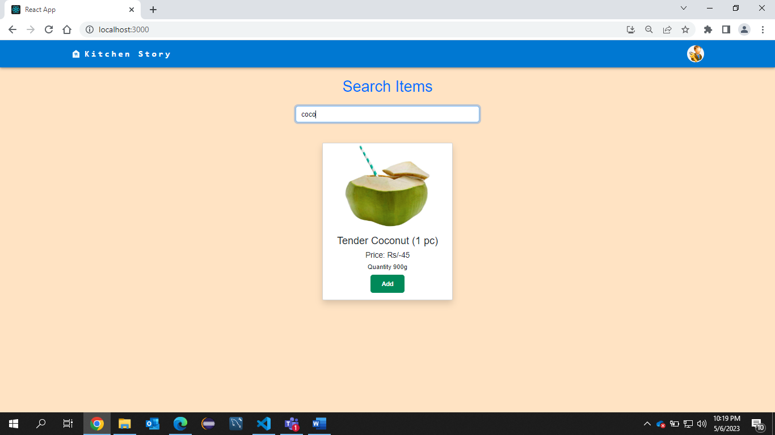

If I Click on a Product



That Product Detailed View will be displayed

Here we have 2 options for Payment COD and Cards

If I select COD and click on buy

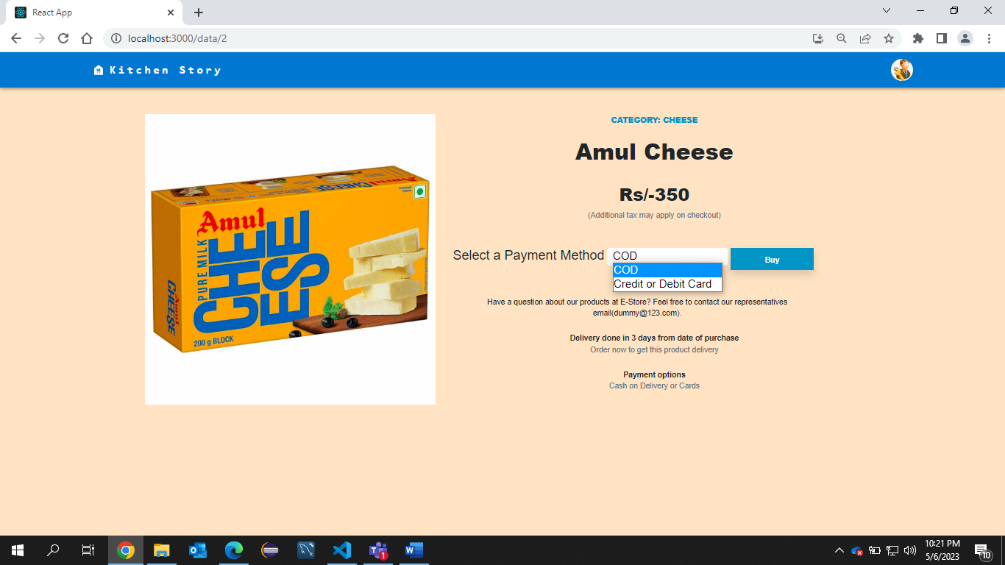

Then we have to enter User Details for Order conformation

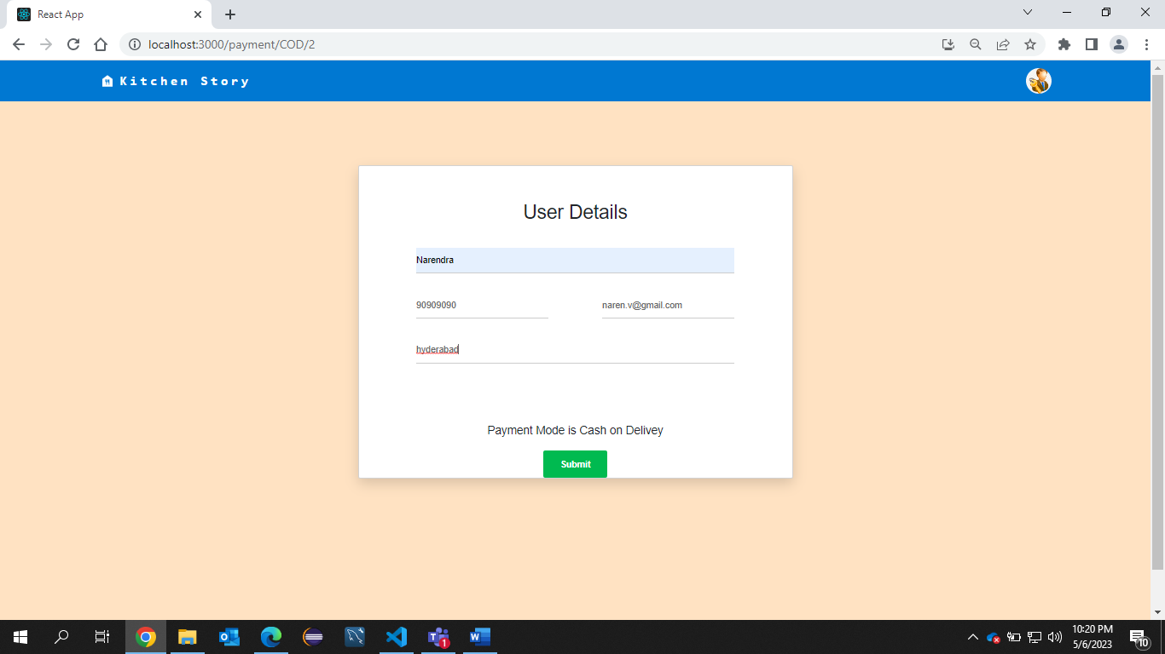

After that order will be placed Successfully

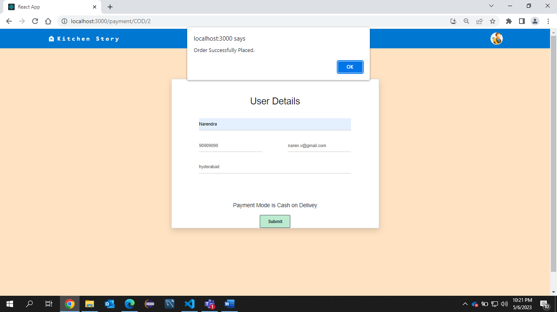

This is the conformation page for order

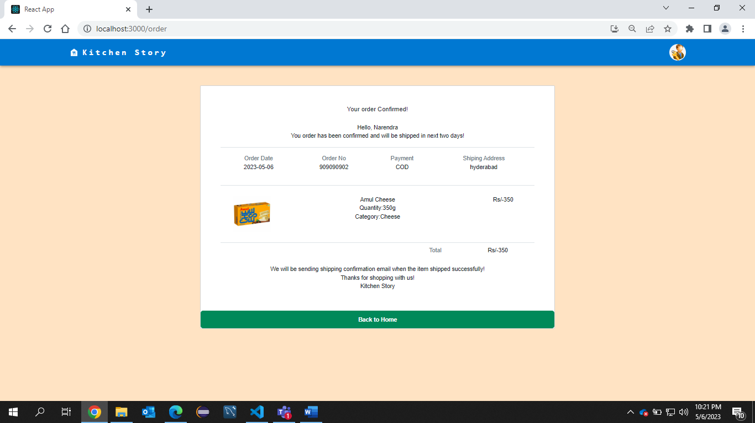

Again Form home page selecting another product

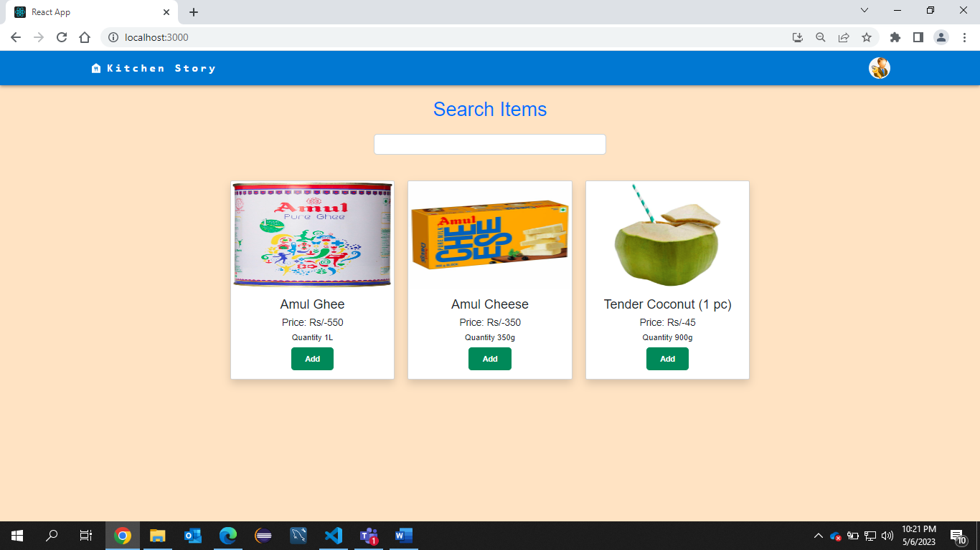

This time I am selecting payment type as Cards

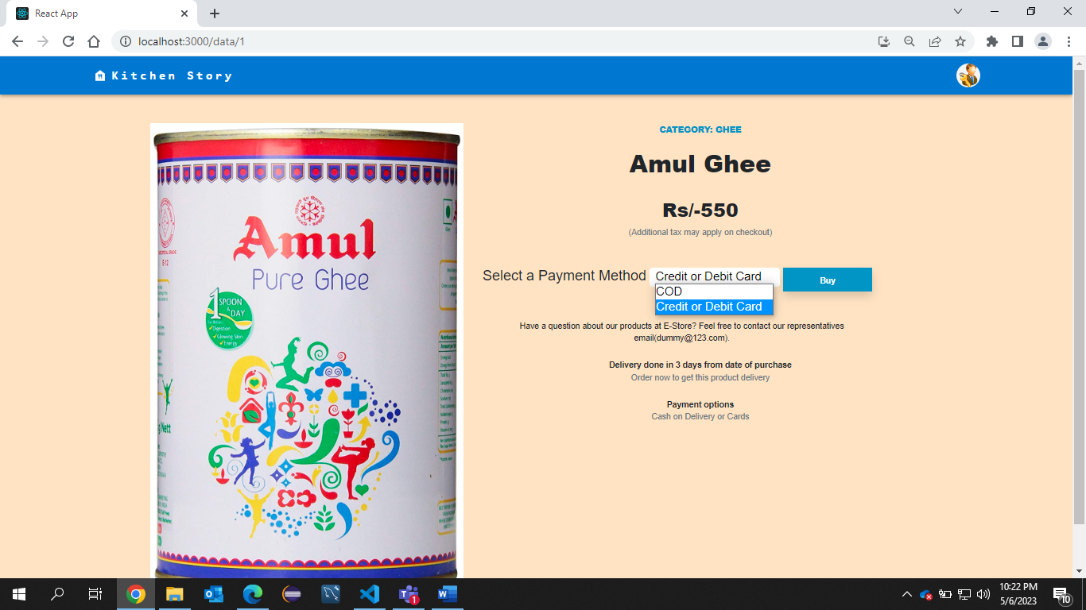

Then I have enter Card details like number Expiry date and CVV along with User details

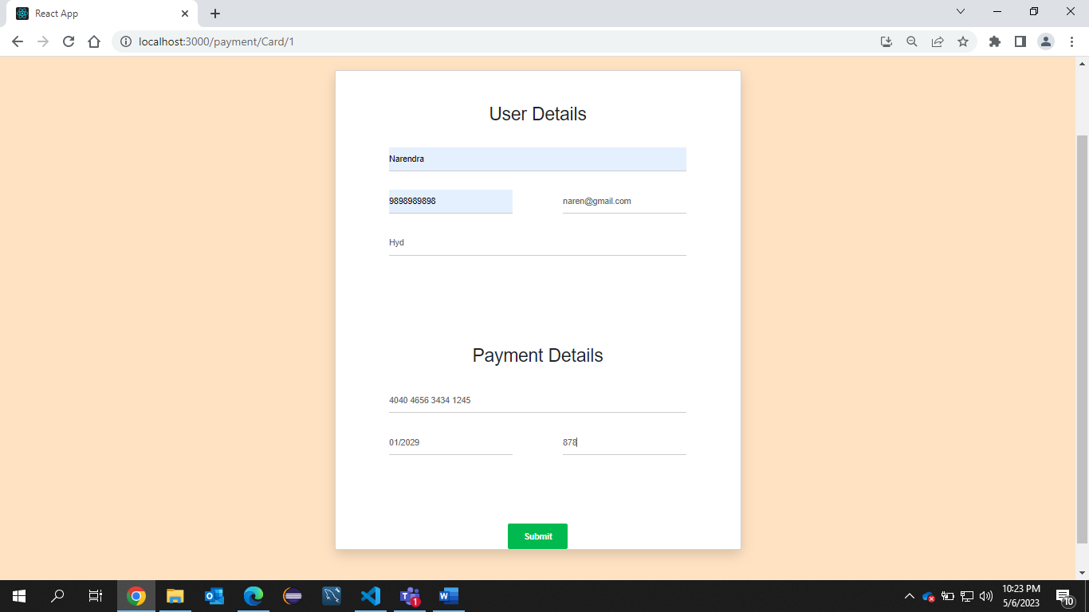

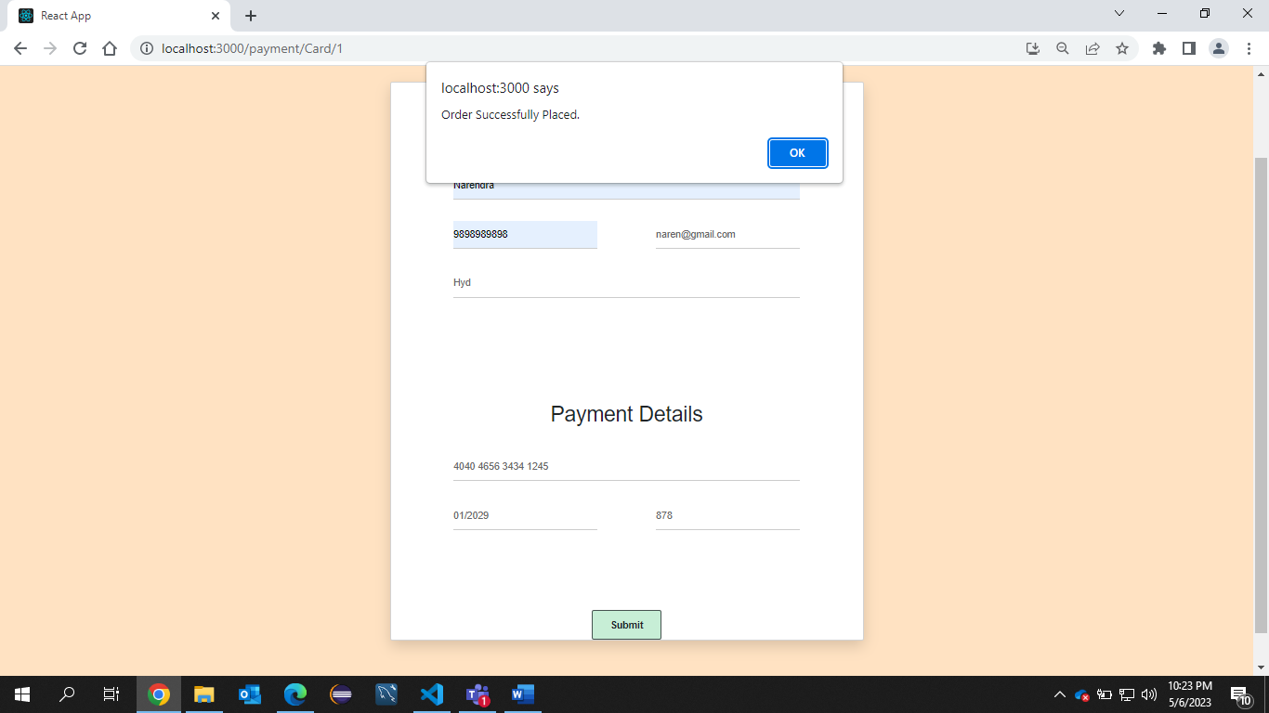

After that order will be placed successfully

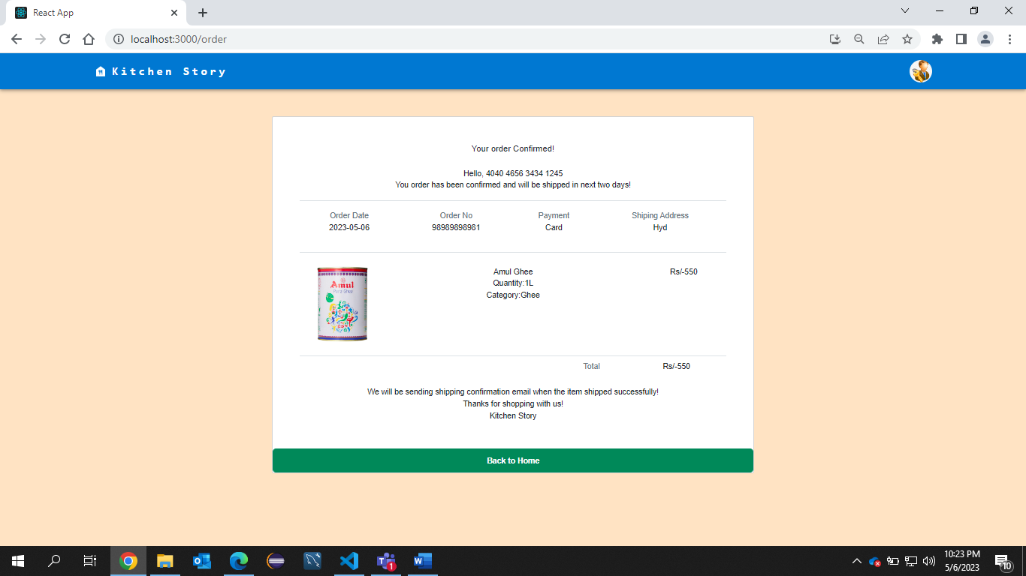

For the Admin Module There is a Button on Right side top As Admin Login

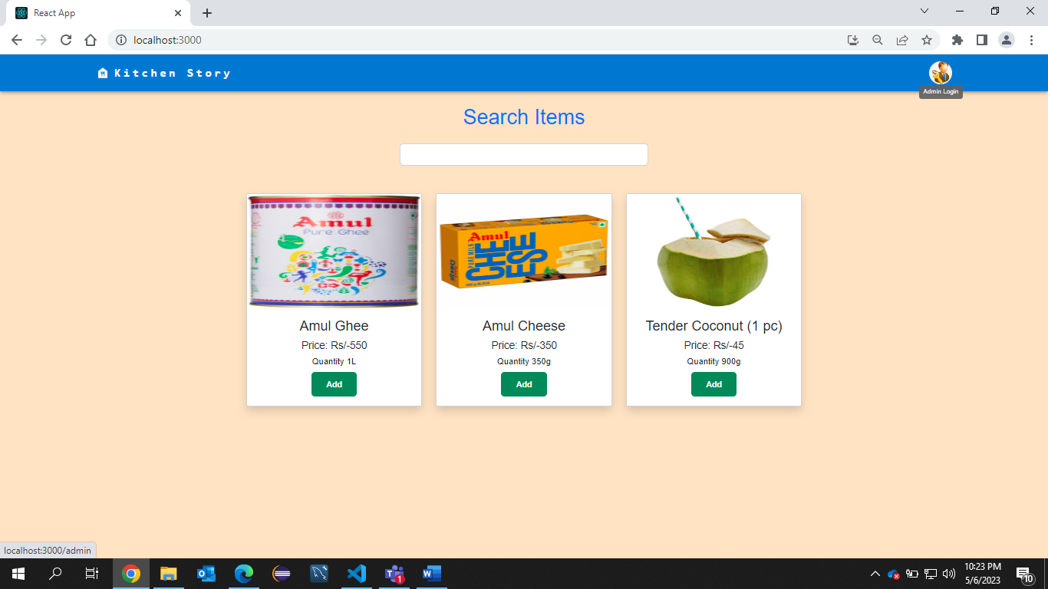

This is the admin login Page

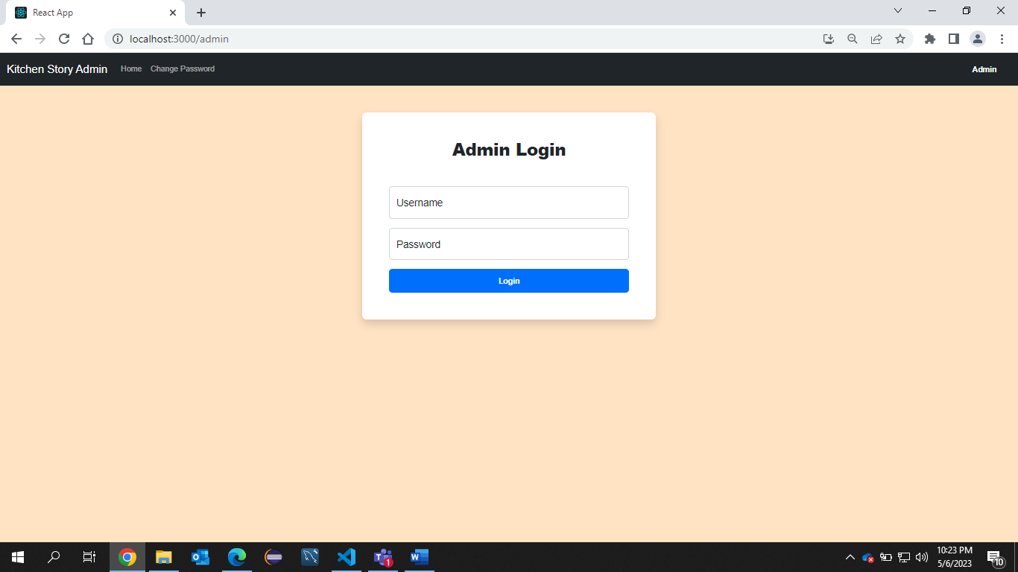

After the Administrator has logged in

He will see a Master list of all Products With add and Delete feature

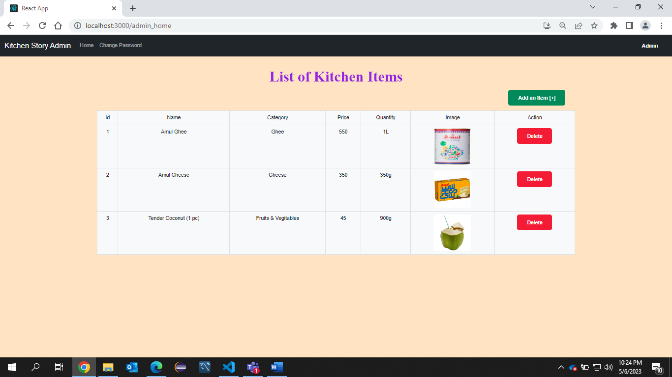

If I click on Additem this page will be displayed

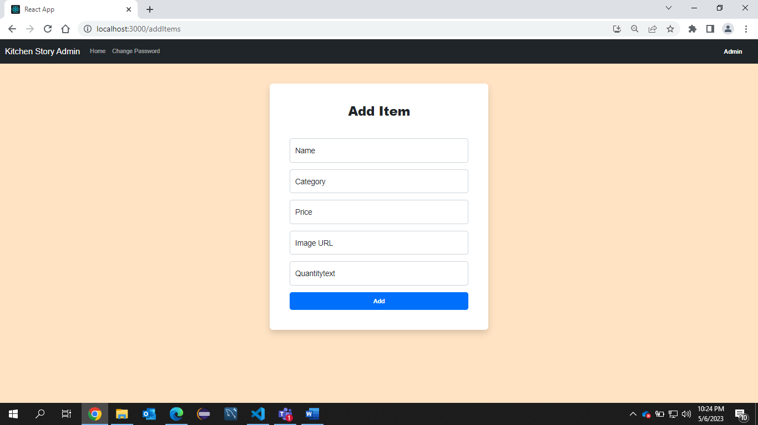

After filling all the details if I click on add

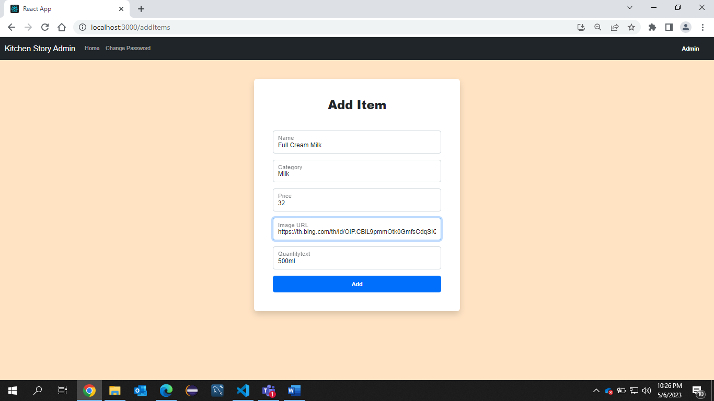

A new Product will be added

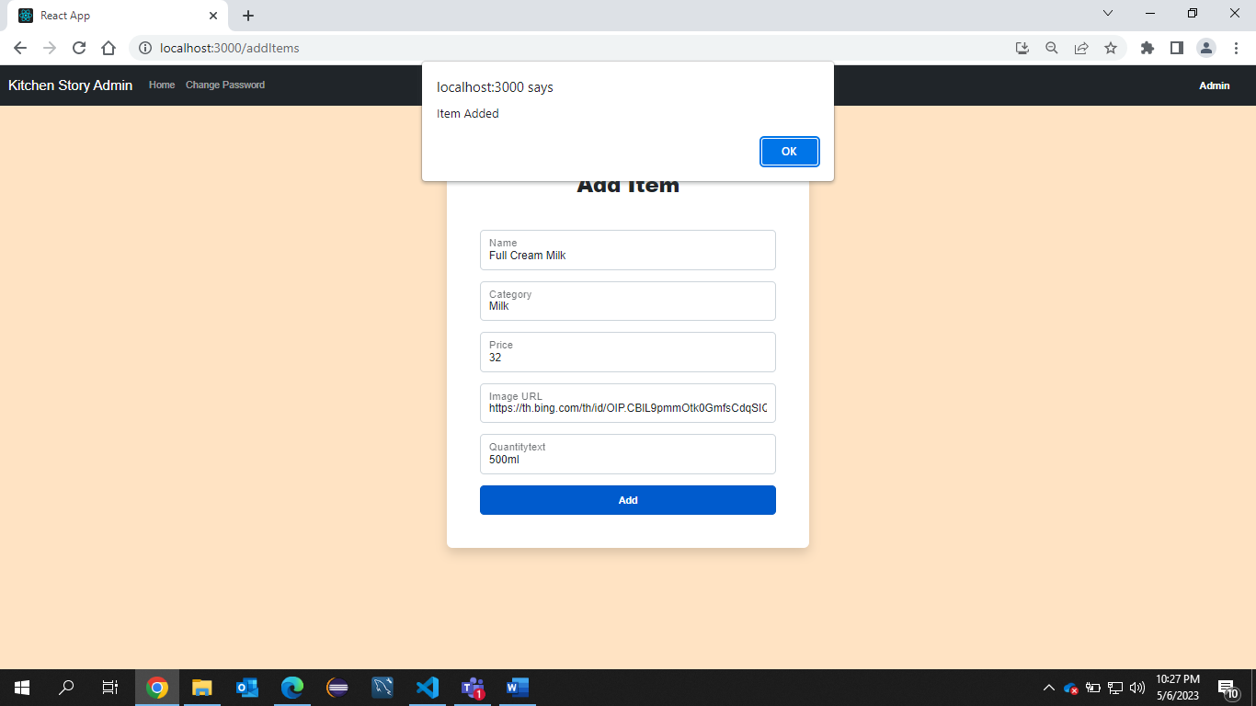

We will be redirected to AdminHome page with newly added item

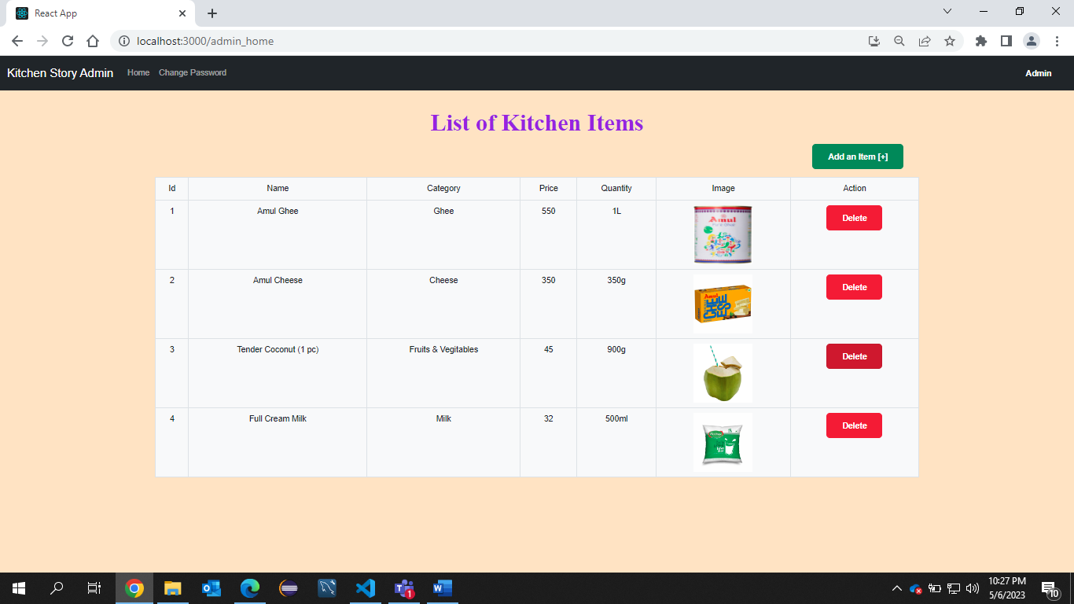

If I click on Delete for 3rd Product That product will be deleted

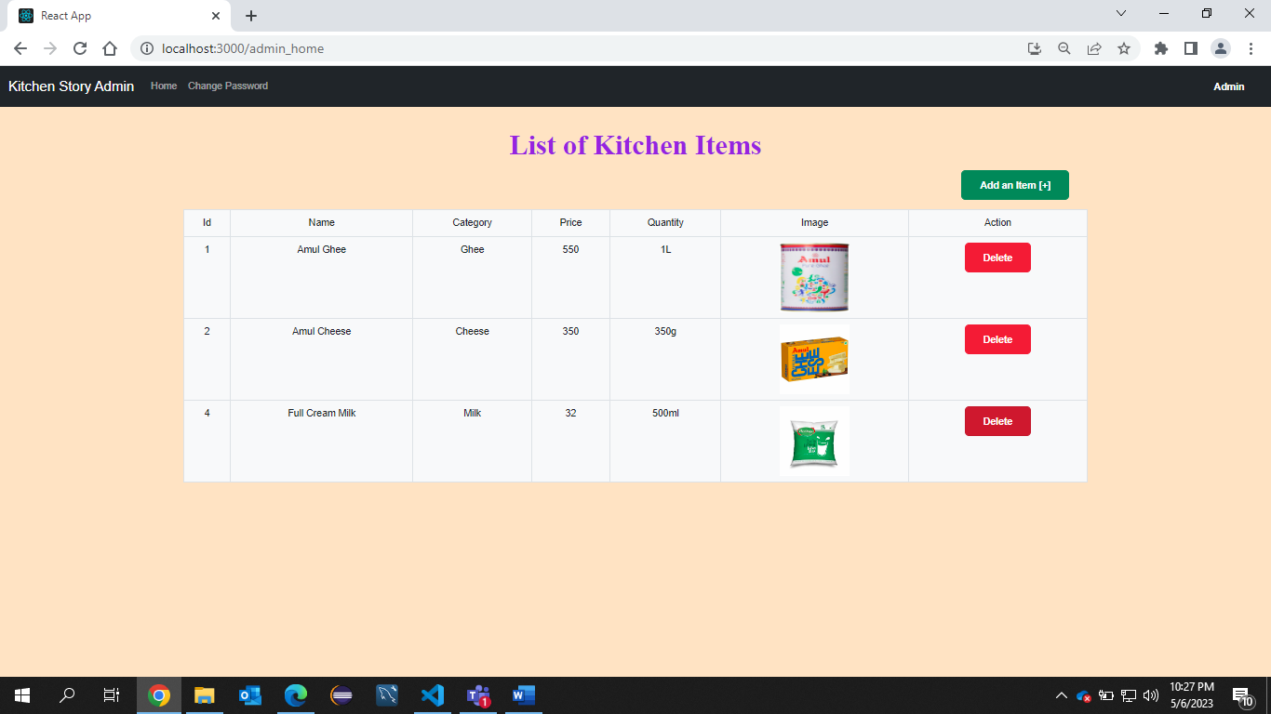

In the Change Password Page If the entered old is wrong then it will display the error

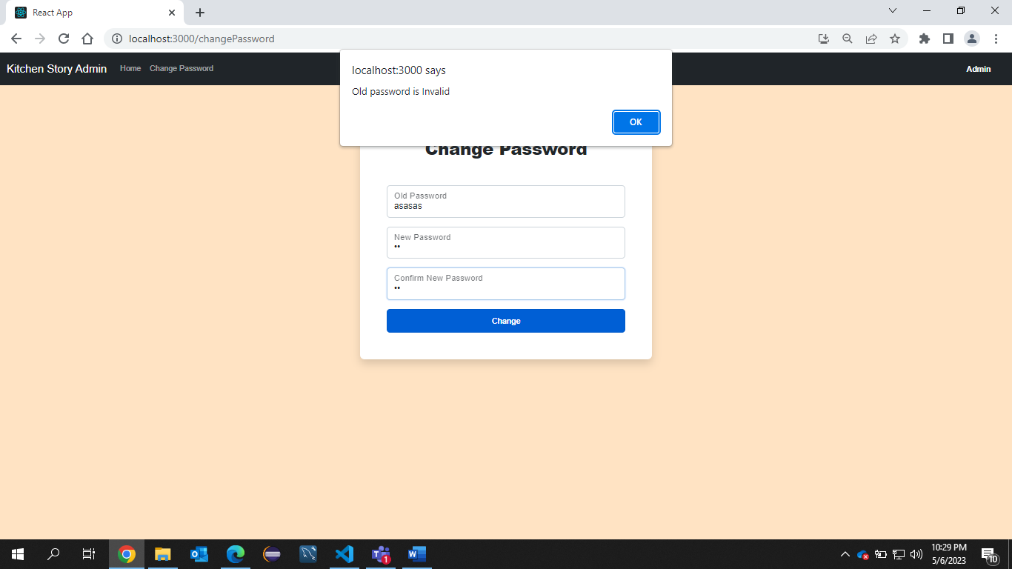

If the New Password and Confirm New Password are mismatched then It will throw an error

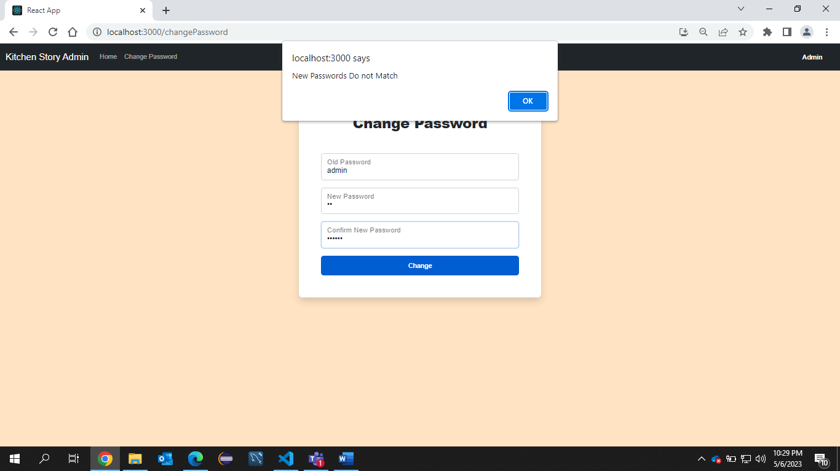

If all the details are entered correctly then Password will be changed Successfully

